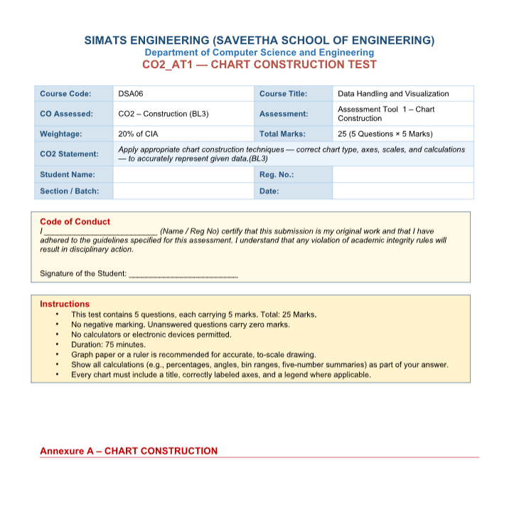
NAME:M.RASHIKA
REG NO: 192573010
COURSE CODE: DSA-0606
COURSE NAME: DATA HANDLING AND VISULAIZATION
CO2
ASSESSMENT -1
Problem 1 — Bar Chart — Basic Construction (5 Marks)
Data: Monthly sales (units): Jan = 120, Feb = 150, Mar = 90, Apr = 200, May = 175.
Task: Construct a bar chart to represent monthly sales. Label both axes, include a chart title, and keep
the months in chronological order.

OUT PUT: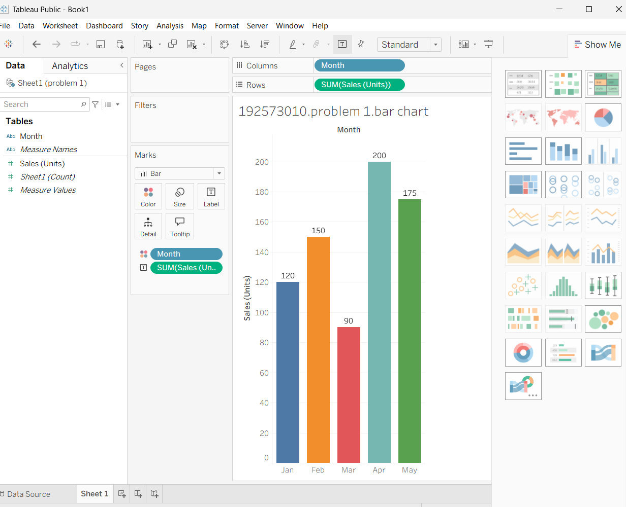

Problem 2 — Horizontal Bar Chart — Ranked (5 Marks)
Data: Website traffic by source (visits): Organic Search = 4,500, Direct = 2,200, Social Media = 1,800,
Referral = 900, Email = 600.
Task: Construct a horizontal bar chart ranking the traffic sources from highest to lowest. Choose and
label appropriate scale intervals on the value axis.
OUTPUT: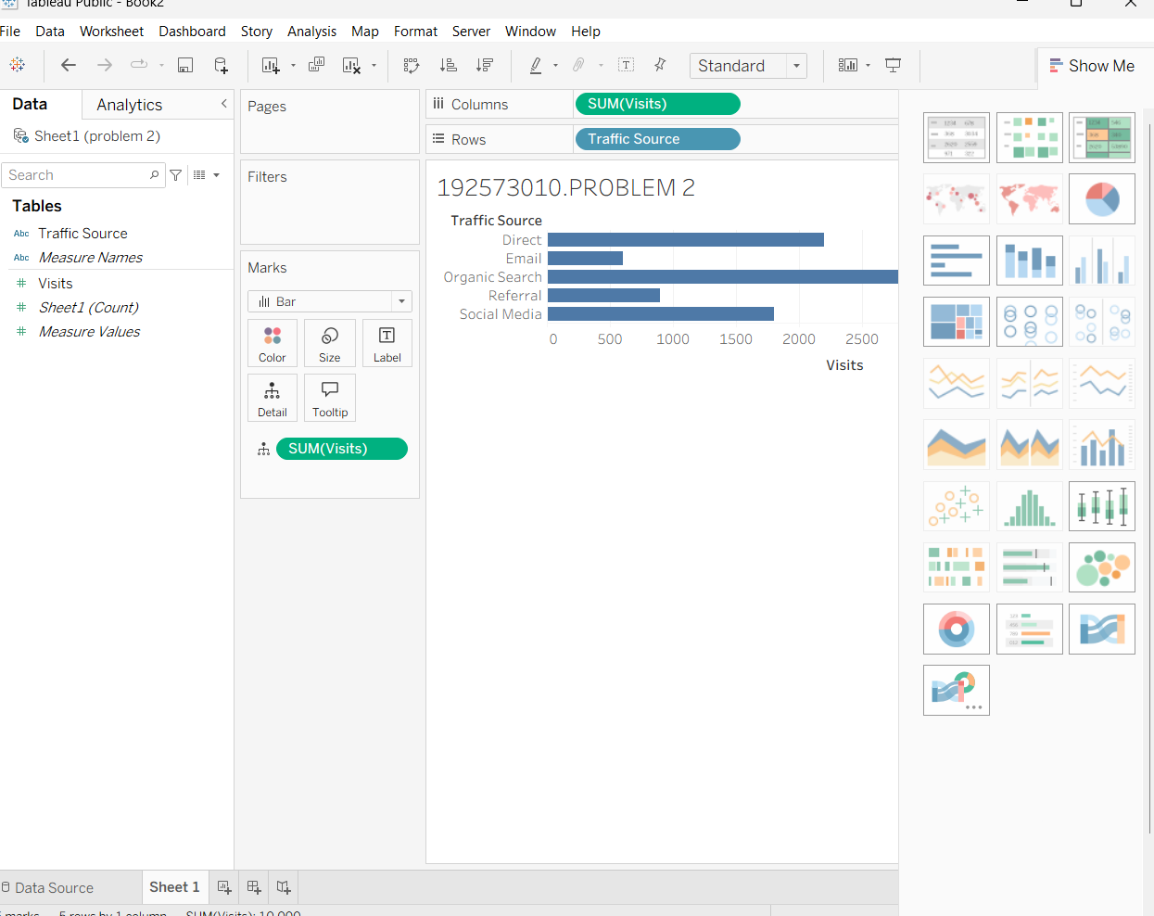

Problem 23 — Treemap — Proportional Area (5 Marks)
Data: Revenue by product category: Electronics=$400K, Clothing=$250K, Books=$150K, Toys=$100K,
Home=$100K.
Task: Construct a treemap where each rectangle's area is proportional to that category's share of total
revenue. Show your calculation of each category's percentage share.
OUTPUT:
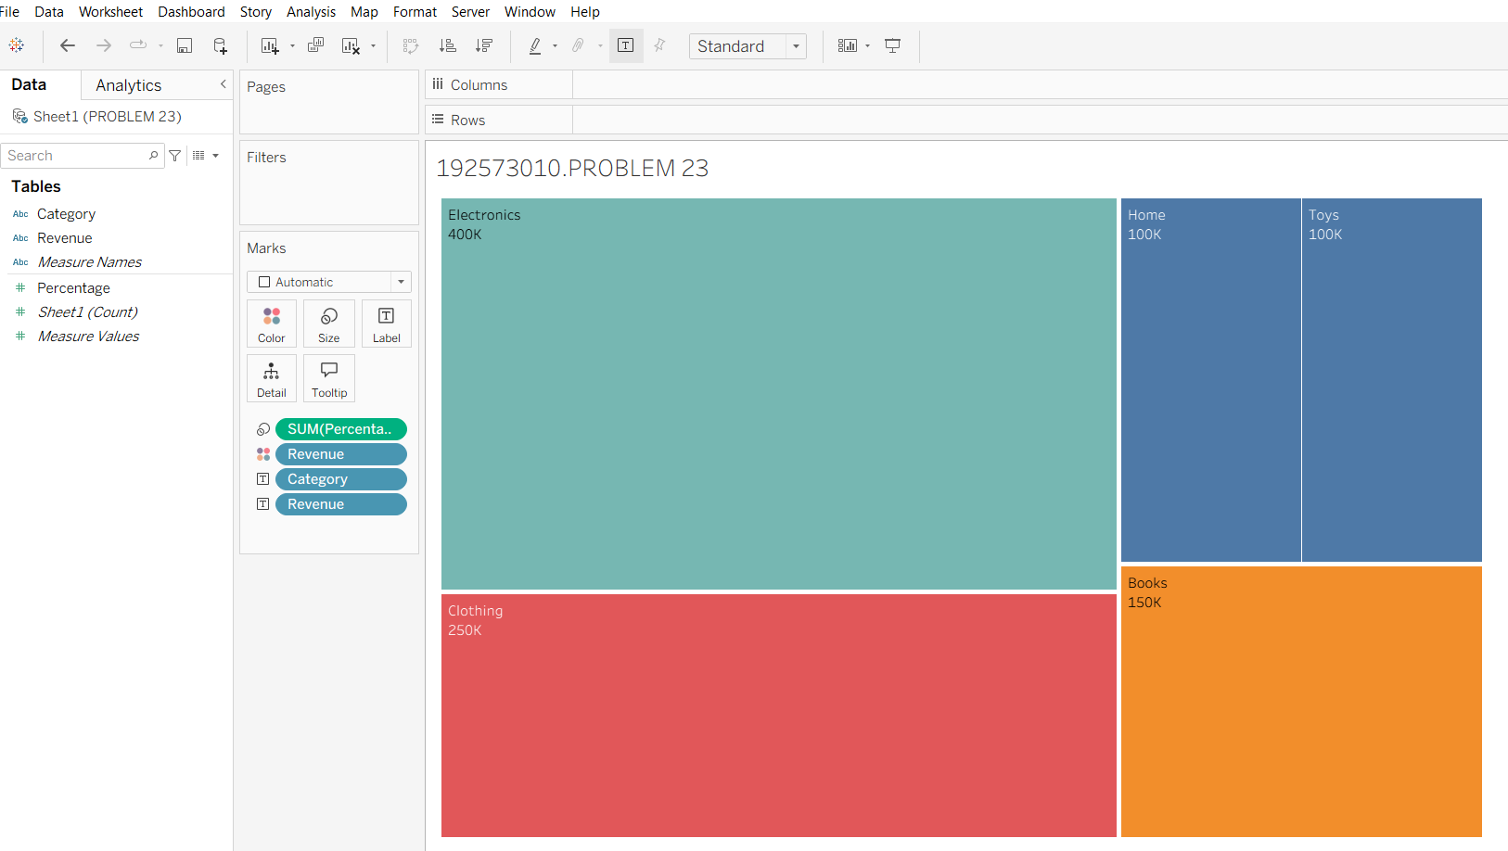

Problem 24 — Combination Chart — Bar + Line (5 Marks)
Data: Monthly sales (units) and average price ($): Jan=(100,20), Feb=(120,22), Mar=(90,25),
Apr=(150,21), May=(130,23), Jun=(160,24).
Task: Construct a chart combining a bar chart (units sold) with a line chart (average price) across the six
months. Explain why you would avoid using a dual y-axis and how you would represent both variables
clearly instead.
OUTPUT:
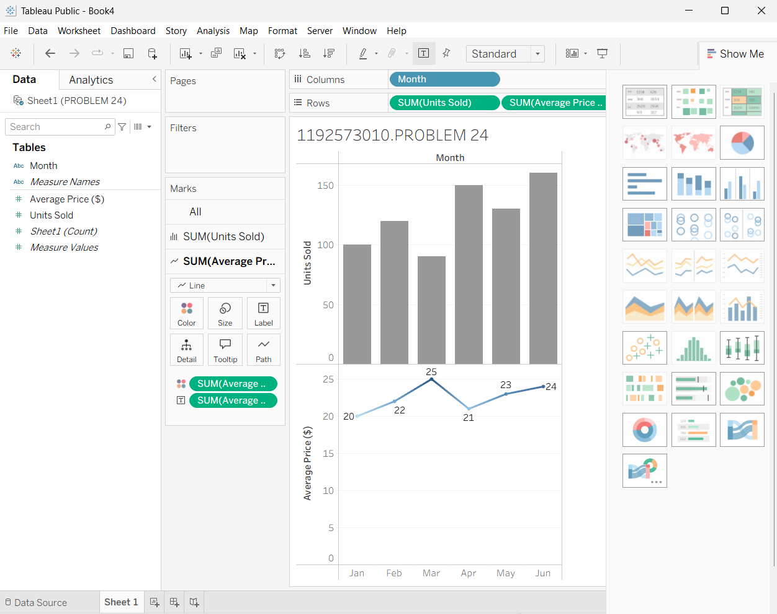

Problem 25 — Small Multiples Construction (5 Marks)
Data: Weekly sales (units) for 4 regions over 4 weeks: Region A: 40, 55, 50, 65 Region B: 30, 35, 45, 40
Region C: 60, 58, 70, 75 Region D: 20, 25, 22, 30
Task: Construct a set of four small-multiple line charts, one per region (rather than one overlaid chart),
and briefly justify this design choice over a single combined chart.
OUTPUT: